**Project Requirements Document for Xamarin Project**

**By James Mullarkey (G00345716)**

**Payroll:**

1. Display json data on the left of the program
2. When an employee is selected, the data shows in the form
3. When save button is clicked it changes the data accordingly on the left
   1. When save button is clicked it saves the new data to the json file
4. When delete is clicked, it changes the data accordingly on the left
   1. When delete is clicked, it is deleted from the json file

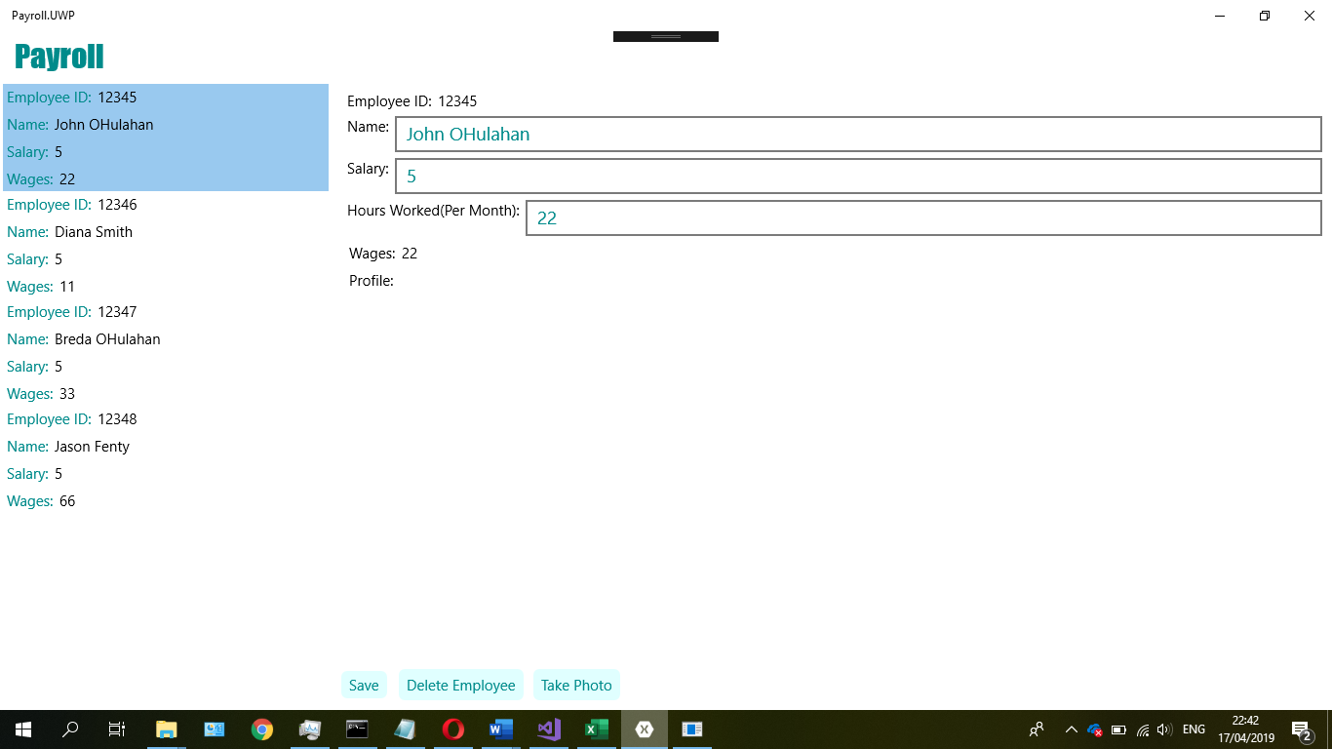

1. When “Take Picture” button is clicked, it should open the camera
   1. When you take a picture with the camera it should show you the photo and ask you to confirm it
   2. If “cancel” is selected, you should be prompted to take another photo
   3. If “done” is selected, the user should be brought back to the application and the photo should be displayed

